DOCENTE

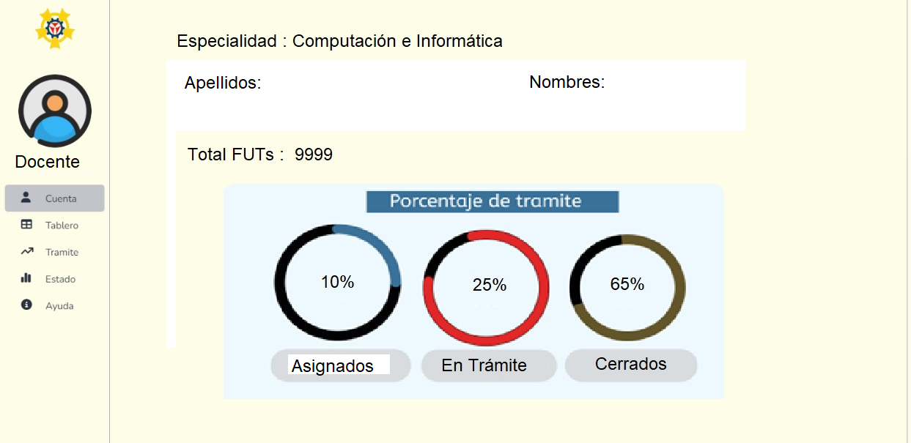

**CUENTA**

Se recuperan los datos de la tabla FUT

**varCodEsp**, debe almacenar el código de la especialidad del docente.

**varCodDocente**, debe almacenar el código del docente

**totalFUT** = select count(1) from fut where añoFut=year(curdate) and codEsp= varCodEsp and codDocente=varCodDocente

**Asignados**= select count(1) from fut where añoFut=year(curdate) and codEsp= varCodEsp and codDocente=varCodDocente and fecHoraNotificaSolicitante is Null

**En Tramite** = select count(1) from fut where añoFut=year(curdate) and estado=’H’ and codEsp= varCodEsp and codDocente=varCodDocente and fecHoraNotificaSolicitante is not Null

**Cerrado** = select count(1) from fut where añoFut=year(curdate) and fecHoraDocenteCierraFut is not null and codEsp= varCodEsp and codDocente=varCodDocente

Color :son comentarios

Procedimiento general

DELIMITER $$

CREATE PROCEDURE contarFutDocente (

IN varCodEsp INT,

IN varCodDocente INT

)

BEGIN

-- Total FUT

SELECT COUNT(1) AS totalFUT

FROM fut

WHERE anioFut = YEAR(CURDATE())

AND codEsp = varCodEsp

AND codDocente = varCodDocente;

Asignados (no notificados al solicitante)

SELECT COUNT(1) AS asignados

FROM fut

WHERE anioFut = YEAR(CURDATE())

AND codEsp = varCodEsp

AND codDocente = varCodDocente

AND fecHoraNotificaSolicitante IS NULL;

En Trámite (notificados y estado H)

SELECT COUNT(1) AS enTramite

FROM fut

WHERE anioFut = YEAR(CURDATE())

AND estado = 'H'

AND codEsp = varCodEsp

AND codDocente = varCodDocente

AND fecHoraNotificaSolicitante IS NOT NULL;

Cerrados (con fecha de cierre del docente)

SELECT COUNT(1) AS cerrados

FROM fut

WHERE anioFut = YEAR(CURDATE())

AND fecHoraDocenteCierraFut IS NOT NULL

AND codEsp = varCodEsp

AND codDocente = varCodDocente;

END$$

DELIMITER ;

Procedimiento separados

Totalfut :

DELIMITER $$

CREATE PROCEDURE totalFUTDocente (

IN varCodEsp INT,

IN varCodDocente INT

)

BEGIN

SELECT COUNT(1) AS totalFUT

FROM fut

WHERE anioFut = YEAR(CURDATE())

AND codEsp = varCodEsp

AND codDocente = varCodDocente;

END$$

DELIMITER ;

Asignados

DELIMITER $$

CREATE PROCEDURE asignadosDocente (

IN varCodEsp INT,

IN varCodDocente INT

)

BEGIN

SELECT COUNT(1) AS asignados

FROM fut

WHERE anioFut = YEAR(CURDATE())

AND codEsp = varCodEsp

AND codDocente = varCodDocente

AND fecHoraNotificaSolicitante IS NULL;

END$$

DELIMITER ;

En tramite

DELIMITER $$

CREATE PROCEDURE enTramiteDocente (

IN varCodEsp INT,

IN varCodDocente INT

)

BEGIN

SELECT COUNT(1) AS enTramite

FROM fut

WHERE anioFut = YEAR(CURDATE())

AND estado = 'H'

AND codEsp = varCodEsp

AND codDocente = varCodDocente

AND fecHoraNotificaSolicitante IS NOT NULL;

END$$

DELIMITER ;

Cerrados

DELIMITER $$

CREATE PROCEDURE cerradosDocente (

IN varCodEsp INT,

IN varCodDocente INT

)

BEGIN

SELECT COUNT(1) AS cerrados

FROM fut

WHERE anioFut = YEAR(CURDATE())

AND fecHoraDocenteCierraFut IS NOT NULL

AND codEsp = varCodEsp

AND codDocente = varCodDocente;

END$$

DELIMITER ;

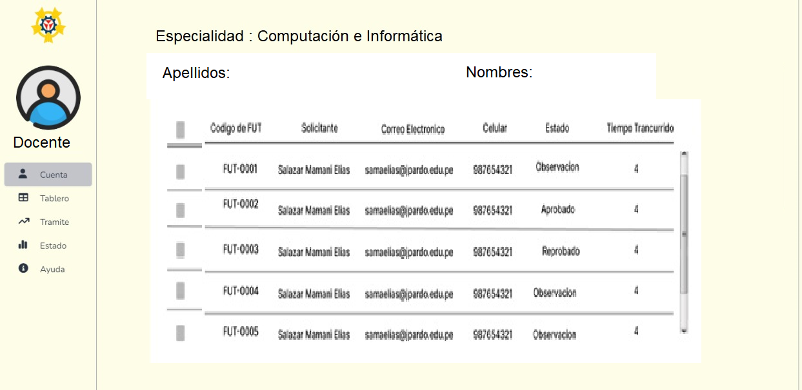

**TABLERO**

Permite visualizar los FUT que le fueron asignados

select nroFut, añoFut,codTT, codSoli from fut where añoFut=year(curdate) and codEsp= varCodEsp and codDocente=varCodDocente and fecHoraNotificaSolicitante is Null

DELIMITER $$

CREATE PROCEDURE tableroDocente (

IN varCodEsp INT,

IN varCodDocente INT

)

BEGIN

SELECT nroFut, anioFut, codTT, codSoli

FROM fut

WHERE anioFut = YEAR(CURDATE())

AND codEsp = varCodEsp

AND codDocente = varCodDocente

AND fecHoraNotificaSolicitante IS NULL;

END$$

DELIMITER ;